**Installation of KVM/QEMU on Ubuntu & Managing KVM/QEMU with virt-manager**

**Installing KVM/QEMU**

1. Install CPU Info Checker

$ sudo apt install cpu-checker

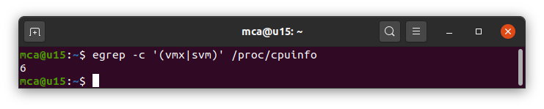

1. Check CPU Info

*$ egrep -c '(vmx|svm)' /proc/cpuinfo*

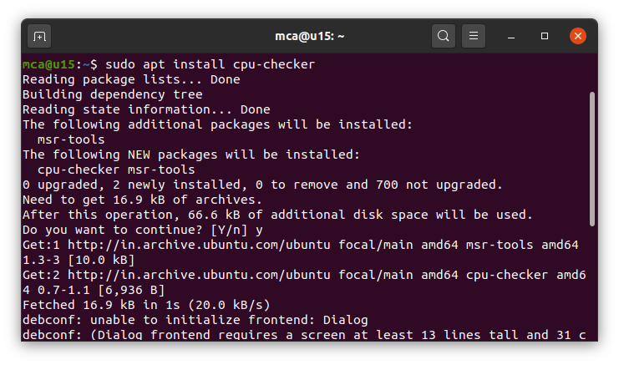

1. Check KVM Status

*$ sudo kvm-ok*

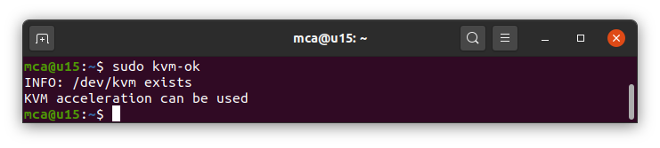

1. Install QEMU/KVM and libvirt

*$ sudo apt install qemu-kvm libvirt-daemon-system libvirt-clients bridge-utils*

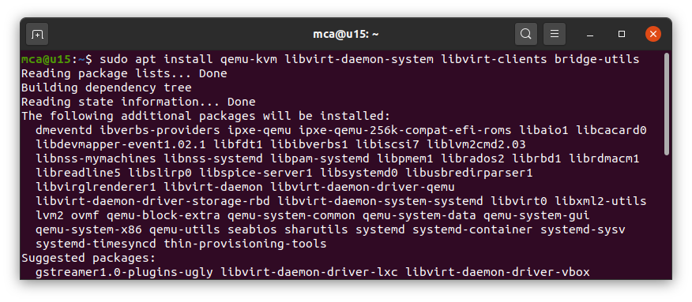

1. Enable libvirt

*$ sudo systemctl enable --now libvirtd*



1. Check libvirt Status

*$ sudo systemctl status libvirtd*

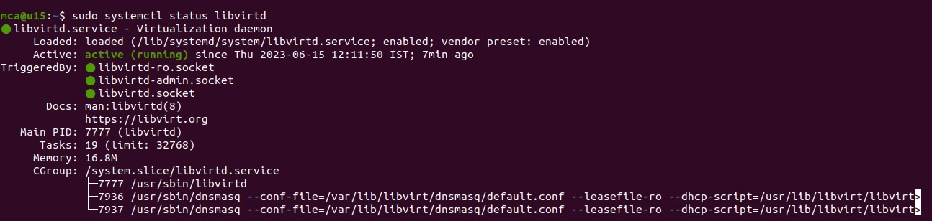

1. Install virt-manager

*$ sudo apt install virt-manager*

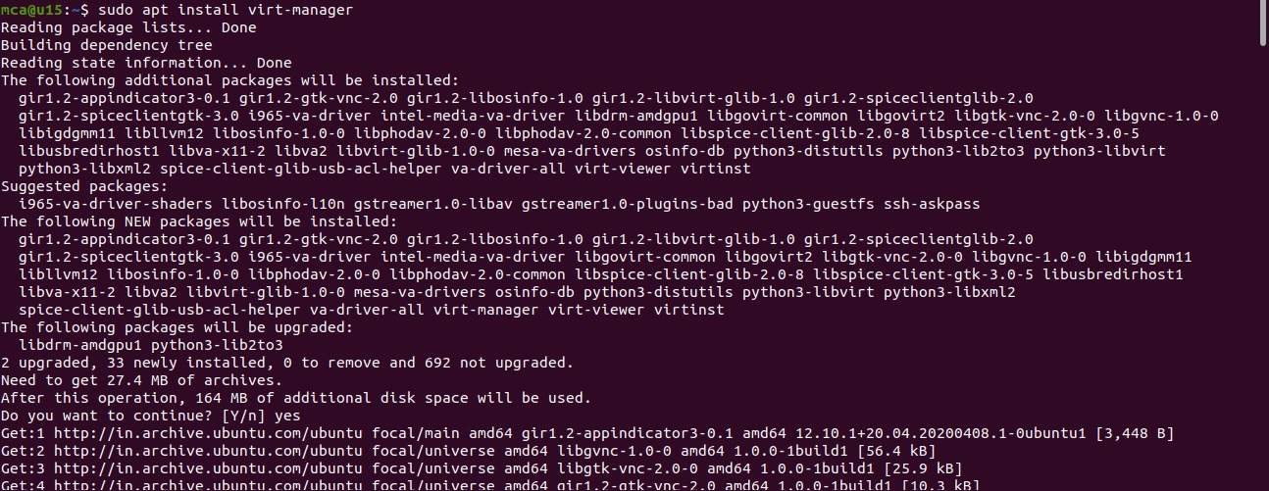

1. Launch virt-manager

$ sudo virt-manager



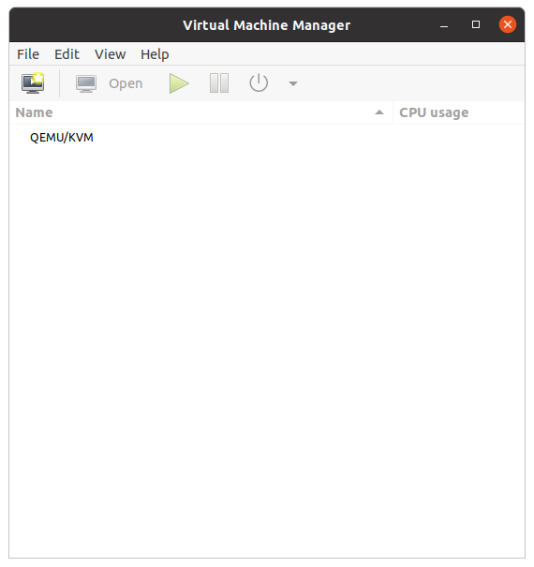

**Installing VM - using ISO image**

* 1. Launch QEMU/KVM



* 1. Create new Virtual Machine

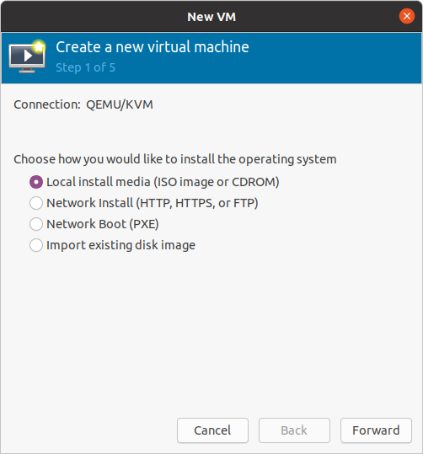

* 1. Choose Storage Volume

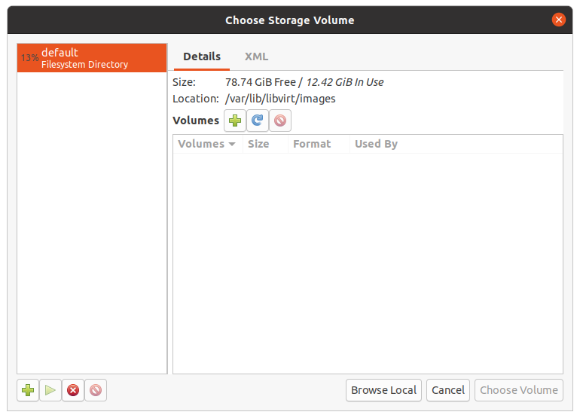

* 1. Choose the ISO Image to Install

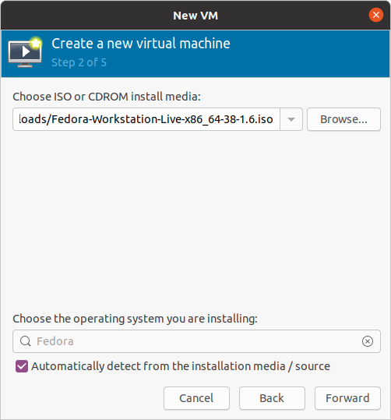

* 1. Configure Memory and CPU

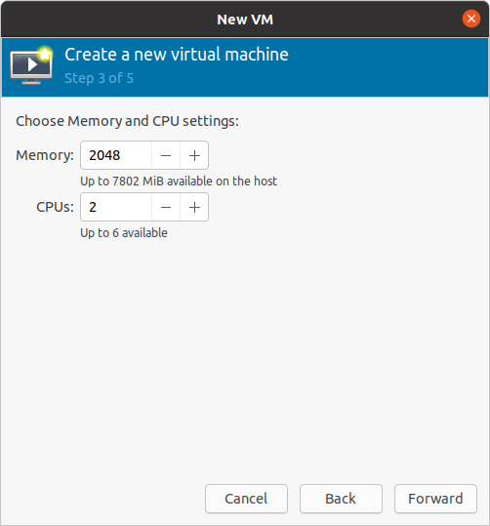

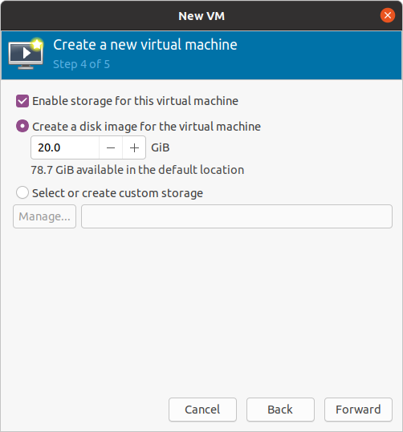

* 1. Configure the VM Name

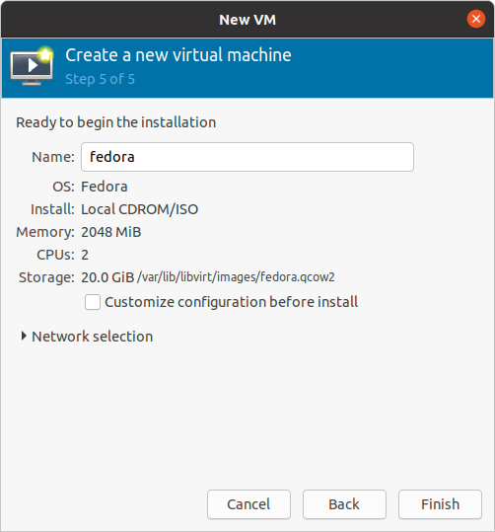

* 1. Installation

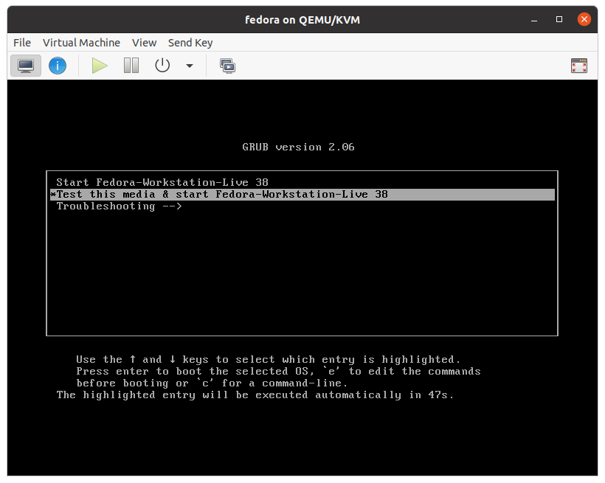

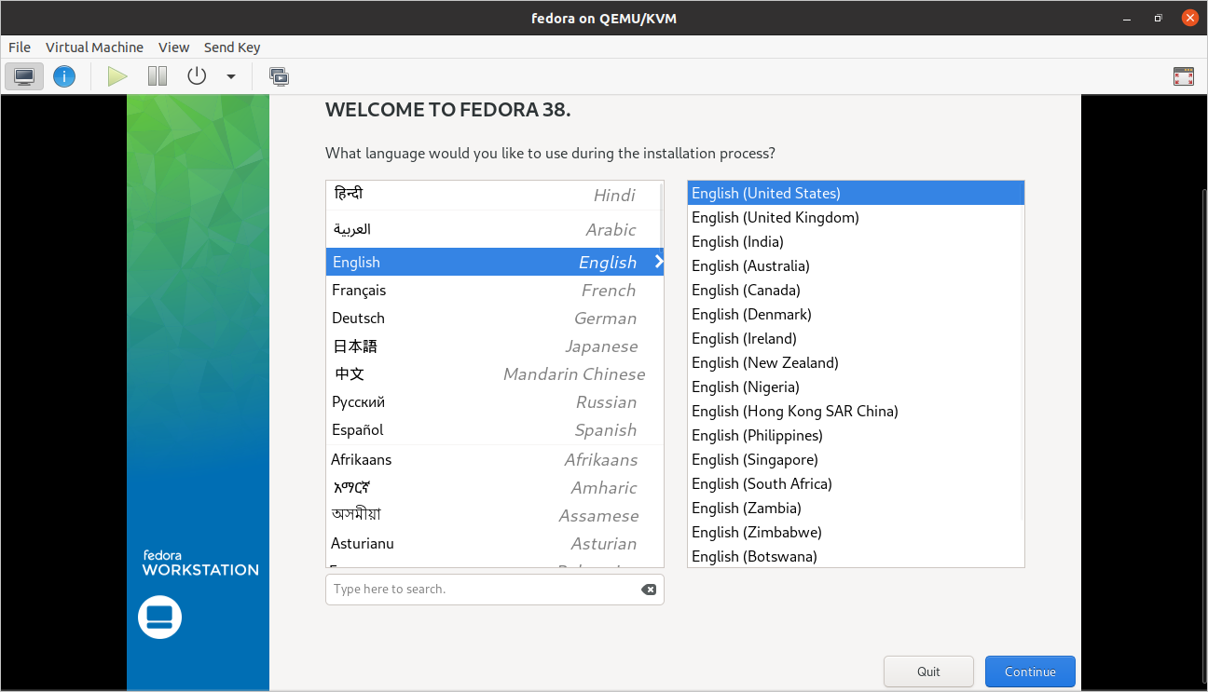

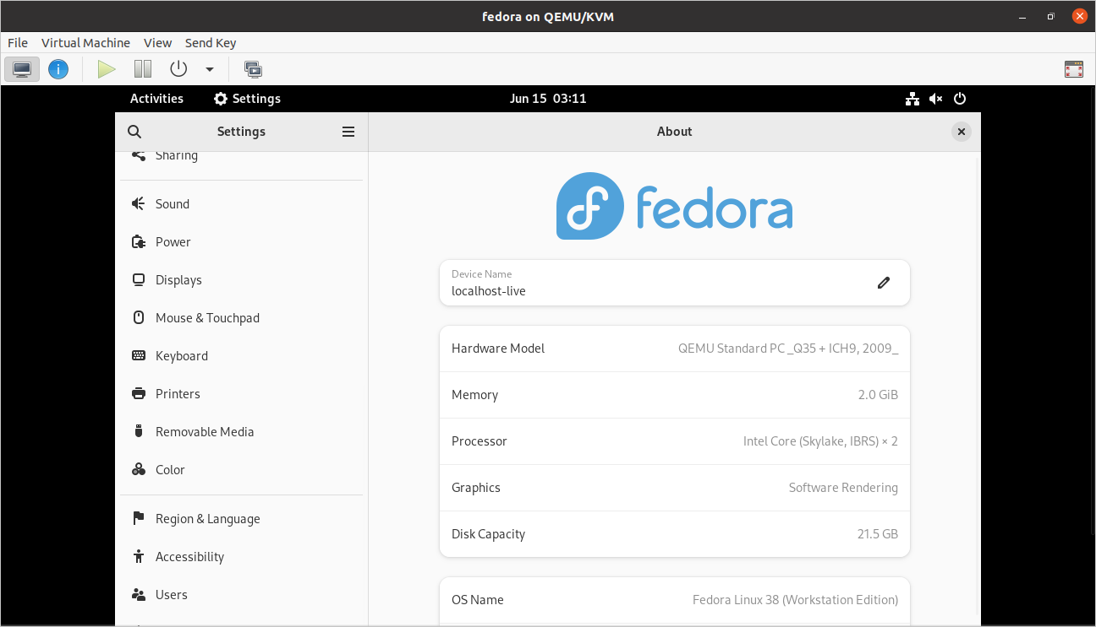

* 1. Virt-Manger Status

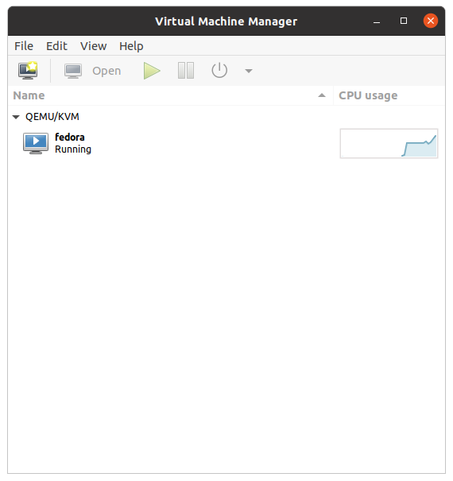

**Managing VMs using Virt-Manager**

1. List all VMs

*$ sudo virsh list –all*

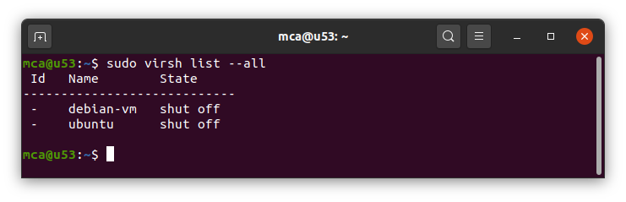

1. Display the Node Information

*$ sudo virsh nodeinfo*

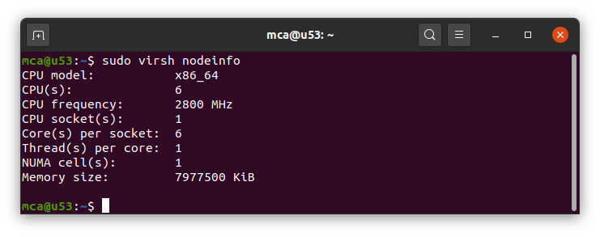

1. Display Help Options

*$ sudo virsh help list*

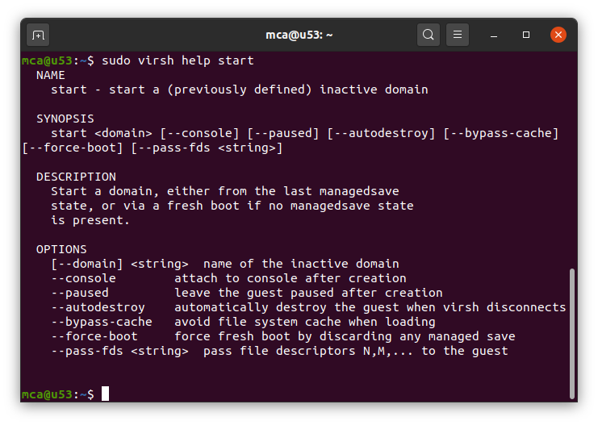

1. Start a VM

*$ sudo virsh start <vmname>*

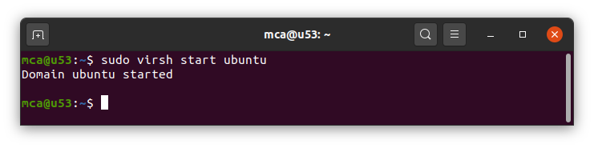

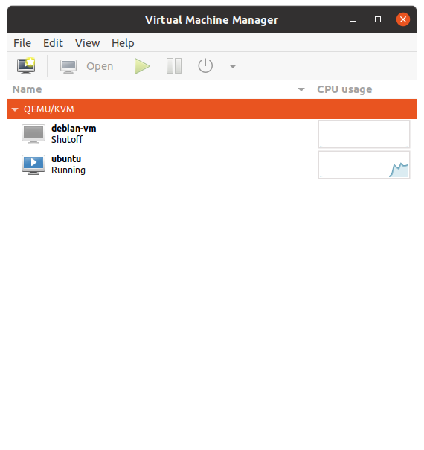

1. Reboot VM

*$ sudo virsh reboot <vmname>*

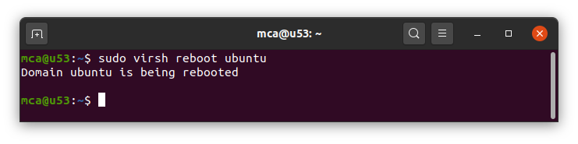

1. Display Domain Info

*$ sudo virsh dominfo <vmname>*

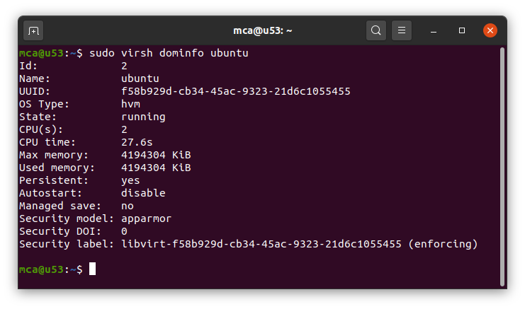

1. Suspend VM

*$ sudo virsh suspend <vmname>*

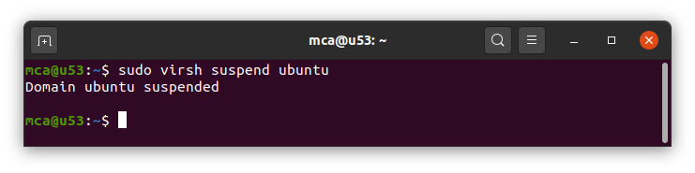

1. Resume VM

*$ sudo virsh resume <vmname>*

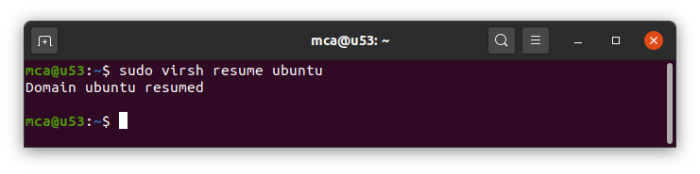

1. Shutdown VM

*$ sudo virsh shutdown <vmname>*

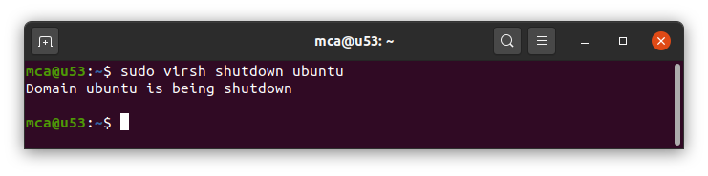

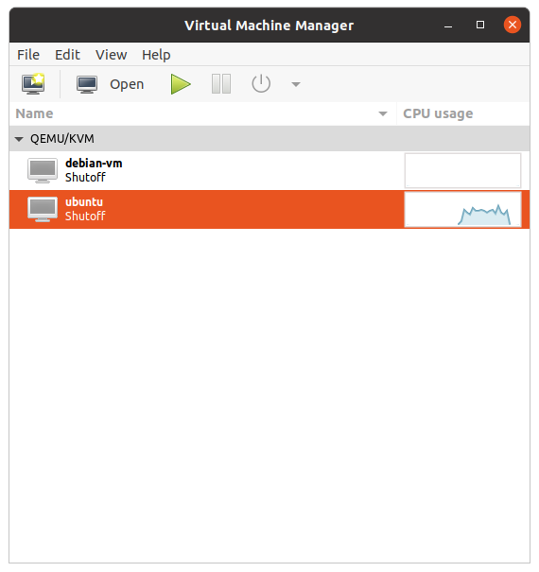

1. Destroy VM

*$ sudo virsh destroy <vmname>*

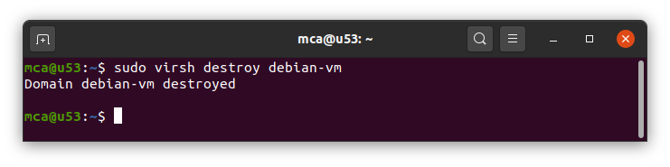

1. Undefine VM

*$ sudo virsh undefine --domain <vmname> --remove-all-storage*

